Bug1
Despite of selecting the agree term, able to register new user successfully
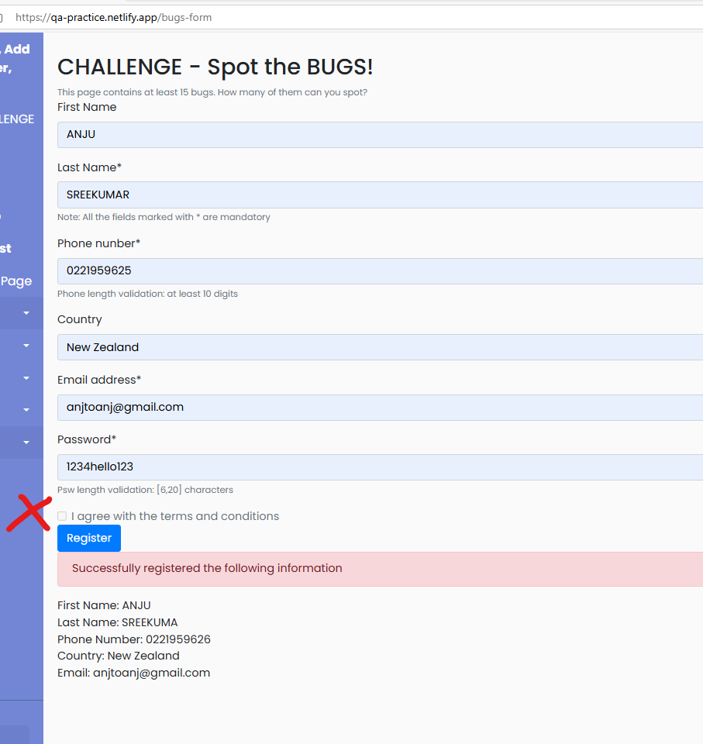

Bug2:
Even without entering details when clicked on Register gives only password condition as error
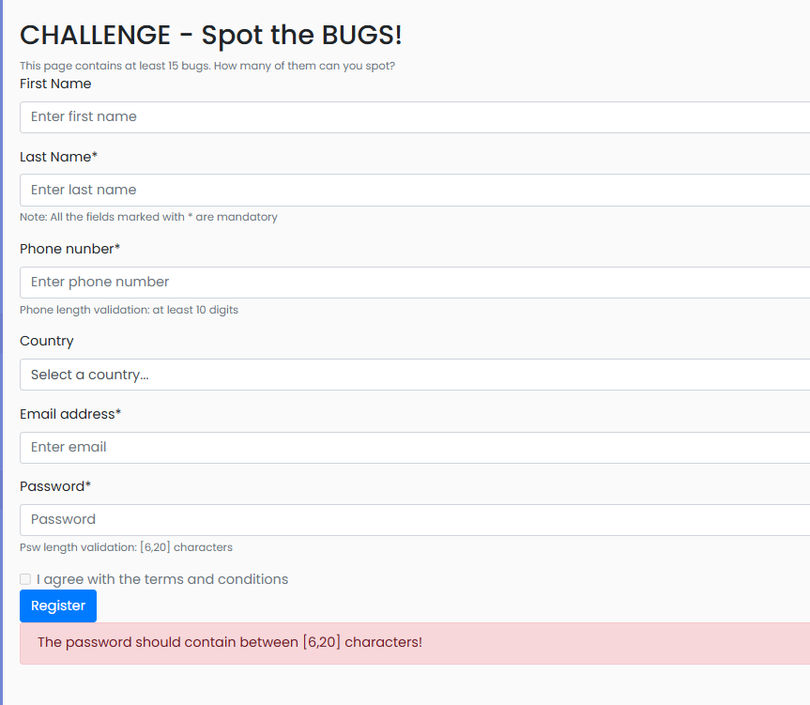
Bug 3
Field validations for lstname, firstname not implemented
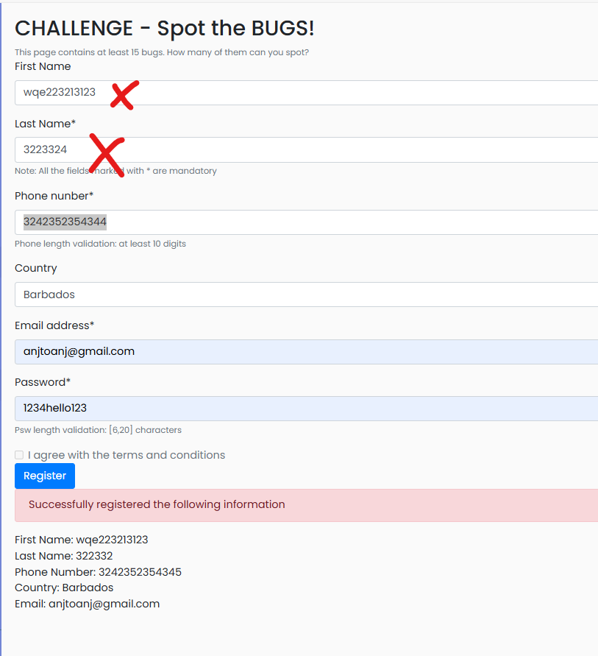
Bug 4:
Mandatory field validations not implemented for lastName, email address
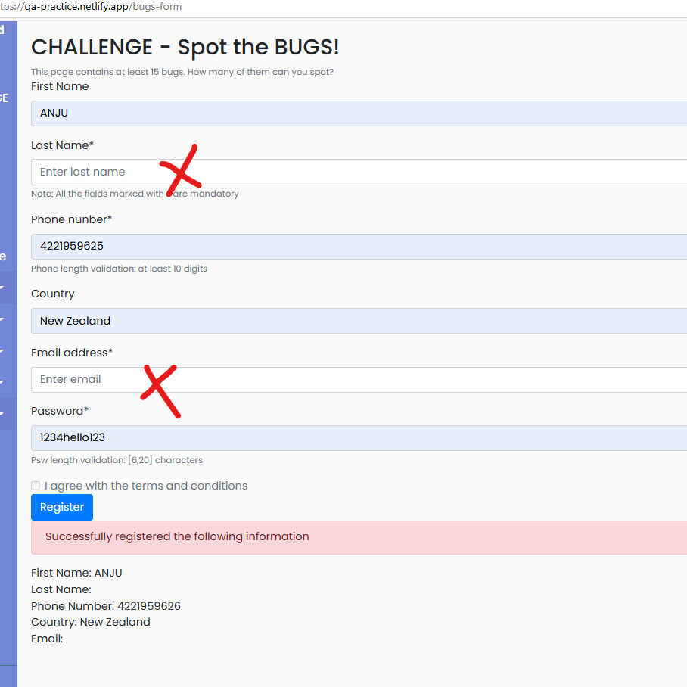
Bug 5
No max limit in phone number and numeric field only allowed validations implemented
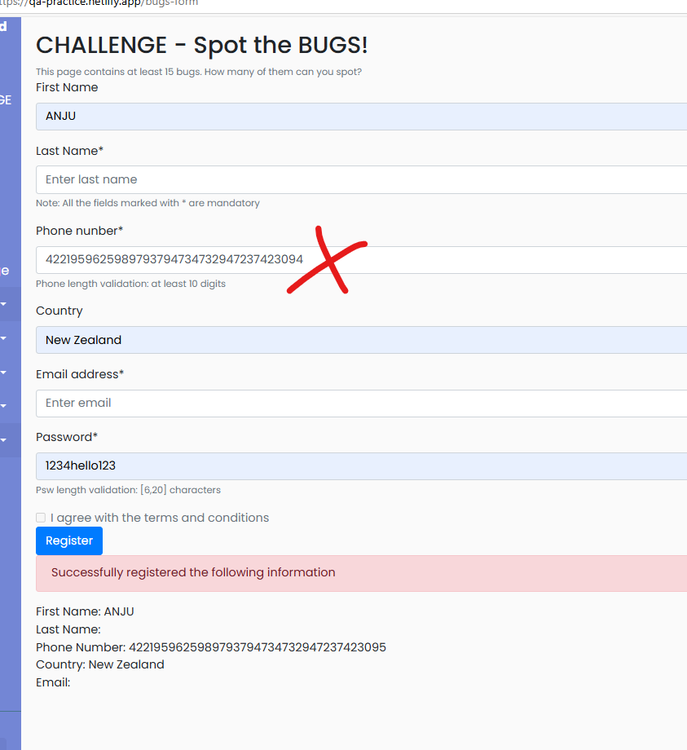
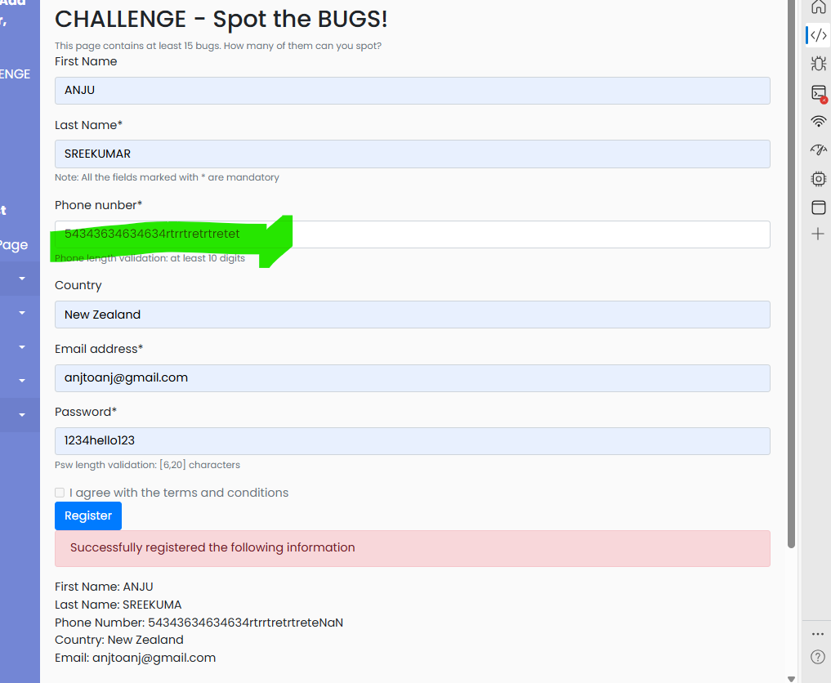
Bug 6
Email Max length validation
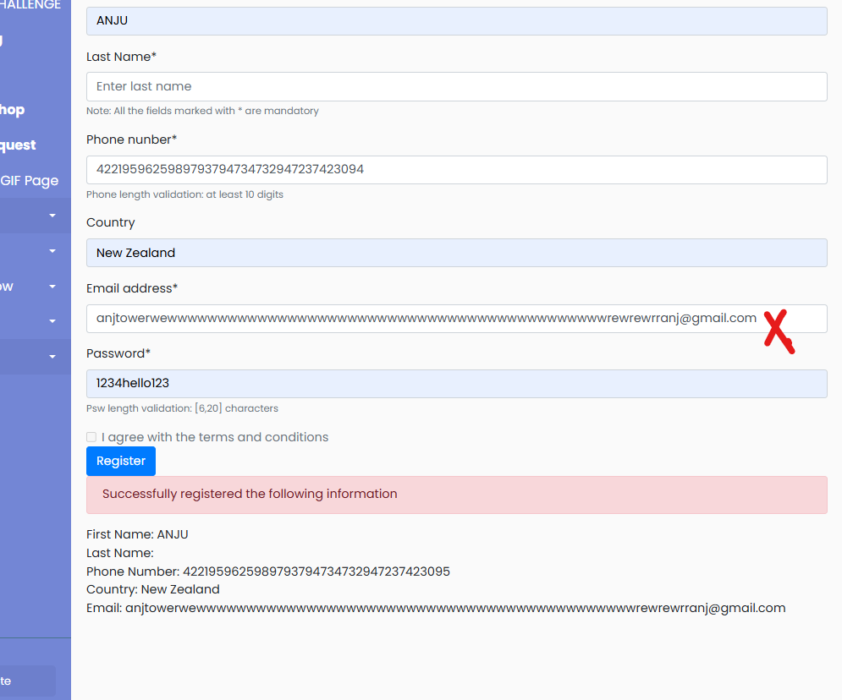
Bug 7
Spelling error in phone number
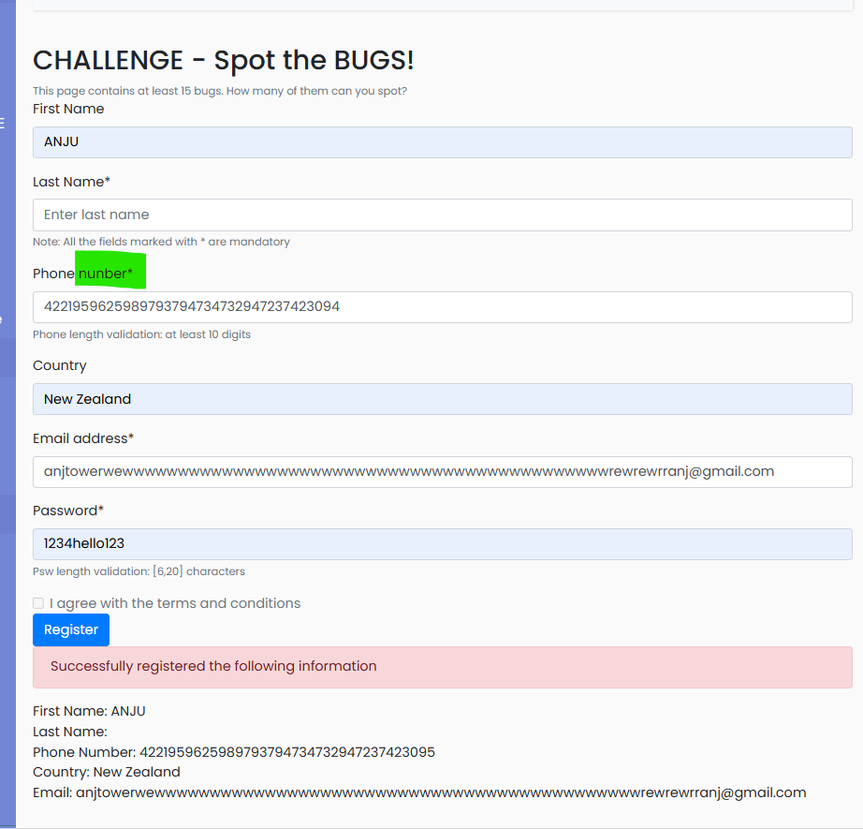
Bug 8
Agree terms is grayed out.
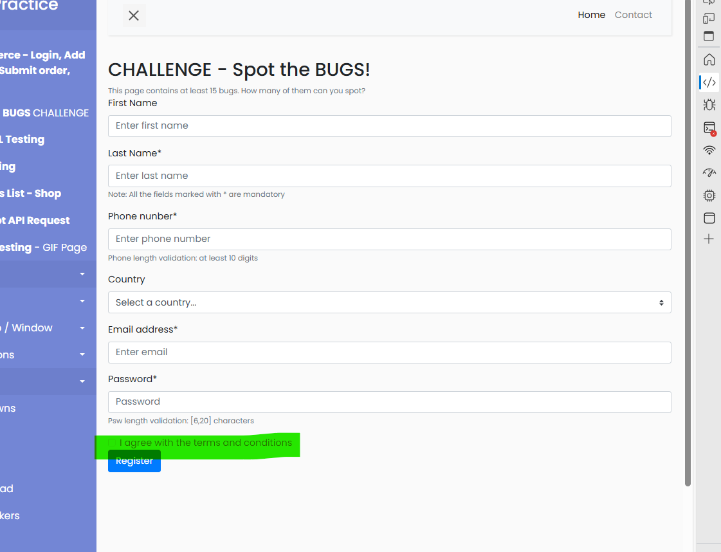

Bug 9:
The validation txt can be more user friendly message like for example– “Password should be maximum 6 to 20 characters”
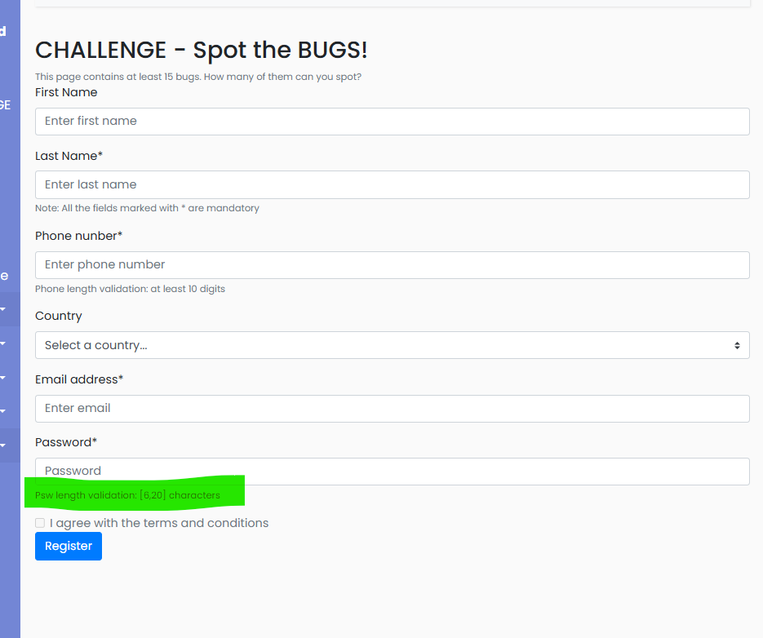
Bug 9

When country is not selected- Select a country option is displayed in Registration successful comment
